Built in function

Built-in functions are the pre-defined function in python. In this article, we will discuss different types of python built in functions with the help of examples.



In Python, several functions and types are built into it that are always available to use. Built-in functions are the pre-defined function in Python that allows using the basic properties of string and numbers in your rules.  
There are 60+ built-in functions in Python, but this article will discuss only the top 13 built-in functions mainly used in Data Science and Machine Learning.

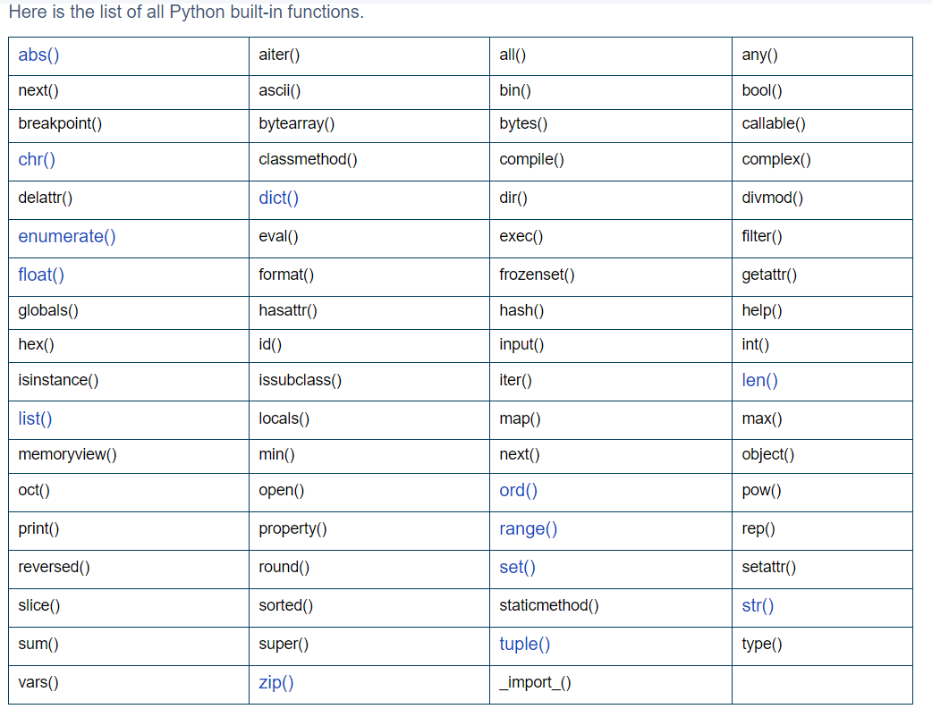

Example:-

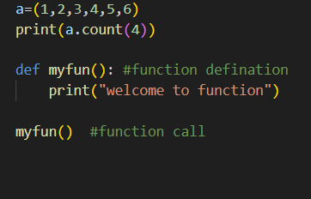

Output:-

